RESEARCH PROPOSAL

ON

**“Title of the research”**

RESEARCH PROPOSAL SUBMITTED TO ……………

FOR ……..

SUBMITTED BY

**Name of the researcher**

This format is given by [**https://phdmates.com**](https://phdmates.com)

**Based on the article –**

[**https://phdmates.com/write-research-proposal/**](https://phdmates.com/write-research-proposal)

**1. Abstract**

***Write down a short abstract, it is not necessary for proposal, but if mentioned or possible, you need to write it down.***

Keywords: add the relevant keywords from your research.

**2. Introduction:**

Write the introduction to your topic. You may follow the blog article on how to write the introduction……… https://phdmates.com/write-research-proposal

# **3. Conceptual Understanding**

*In this section, write down the definitions of the keywords, the process methods in very descriptive manner. Explain the variables that would be involved. You can write it in points if necessary.*

Sub-Points -

* **Point 1: description**
* **Point 2 : description**
* **Point 3:**

## **3.1 subtopic 1**

*Add the description and all the knowledge that you have found.*

**3.2 subtopic 2**

*Add the description and all the knowledge that you have found.Bottom of Form*

**3.3 subtopic 3**

*Add the description and all the knowledge that you found.*

*You may also create images, diagrams features that you may add here as an example, I have added it below.*

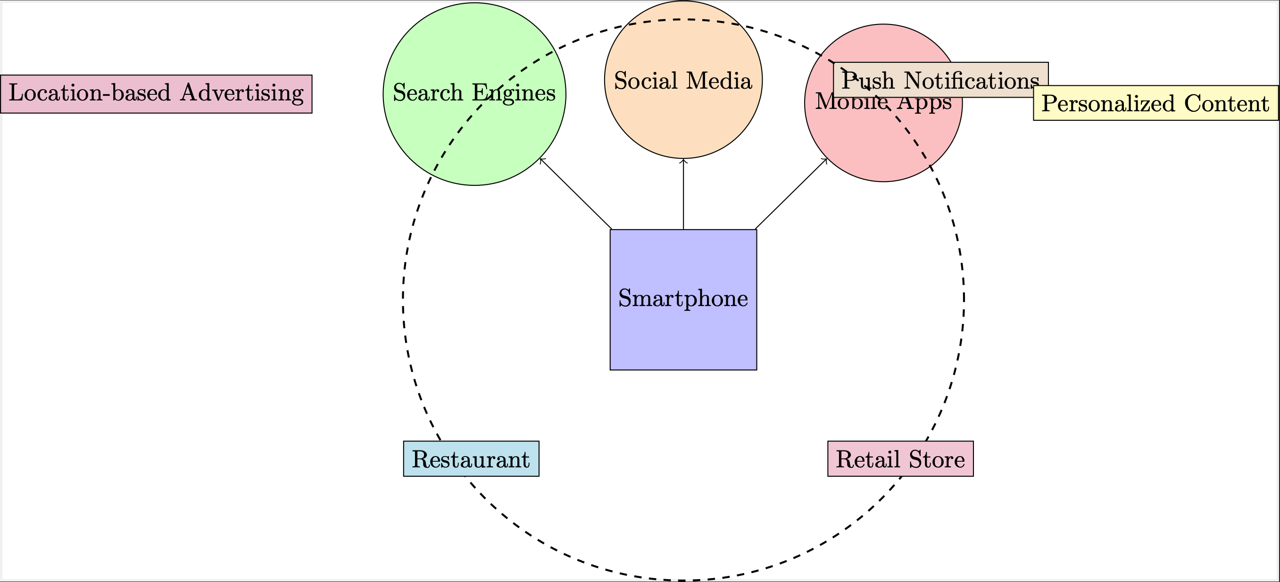

**4. Literature Review**

*Write the literature review as an example I have provided it below. You may add 8 to 10 literature reviews..*

**“Shaik Javed Parvez1, H.M. Moyeenudin, S. Arun R., Anandan4, Senthil Kumar Janahan”** Has described that Digital Marketing can be very beneficial for the hotels as it is low cost and good for promotional materials. Social Media platforms like Instagram & Facebook can be used for showcasing hotel promotional videos. Also Website of the Hotel plays a major role as the hotel can optimise it to appear it on the search results.

**5. Research Gap**

*Research gap you need to identify the gaps that you might have found in literature review and mention it. You can follow the article in which I have told you how to write research gap. The research will be based on the studies that have been done earlier and the current changes that makes you that there should be further research conduct.*

**6. Research Questions**

You can add 4 to 5 research questions here.

1. Research question 1
2. Research question2
3. Research question3
4. Research question4
5. Research question5

**7. Problem Area:**

*In problem area, you may write about the problems that you may face while doing the research or the limitations that you may face. You may write it point wise.*

**8. Objectives**

*Write down 4 to 5 research objectives point wise.*

1. Object objective1
2. Research object2
3. Research object3
4. Research object4
5. Research objective on providing recommendations.

**9. Need of the Study:**

*Write down about why do you feel the need of the study you may mention 2 to 3 points.*

**10. Research Methodology:**

The research methodology will involve conducting semi-structured interviews with industry professionals. Online surveys targeted at customers who have engaged with hotel marketing campaigns.

* 1. **Type of Research:**.
  2. **Population:**.
  3. **Sample Size:**.
  4. **Sampling Method:**
  5. **Data Collection:** There are two types of data collection methods,

1. Primary Data (Through Structured Questionnaire)
2. Secondary Data (Through Thesis, Research Journals, Conference Proceedings, Website, Reports)

In my study, both data collection methods will be used.

* 1. **Data Analysis:** The collected data will be analysed using descriptive statistics, inferential statistics, and regression analysis to identify patterns and relationships between Geolocation based marketing strategies and customer reach over time. In my study, two types of analysis will be used.

1. **Graphical Analysis** – By using graphs and tables.
2. **Statistical Analysis** – a. Chi-Square Test

b. Ratio Analysis

c. Z Test

d. P Test

**11. Hypothesis:**

*Provide at least three hypothesis with alternate hypothesis.*

H1:

H2:

H3:

H4:

**10. Limitations of the Study:**

a.

b.

c.

**12. Benefits of the Study:**

*Write down about stakeholders that may benefit benefit from this research that you would be conducting. Write down about every stakeholder. For example example, if you’re writing about hotels, you may write about the customer hospitality industry, the owner and the government.*

**13. Bibliography**

*Put down all the references that you have referred to in this section. An example I have listed one below..*

1. Shaik, Javed & Moyeenudin, H.M. & Sahayadhas, Arun & R, Anandan & Janahan, Senthil Kumar. (2018). Digital marketing in hotel industry. International Journal of Engineering & Technology. 7. 288. 10.14419/ijet.v7i2.21.12383.